Phase-2

TechnologyArchitecture

|  |  |
| --- | --- |
| Date | 28October2022 |
| TeamID | B2-2M4E |
| ProjectName | Project-InventoryManagementSystemforRetailers |
| MaximumMarks | 4Marks |

TechnicalArchitecture:

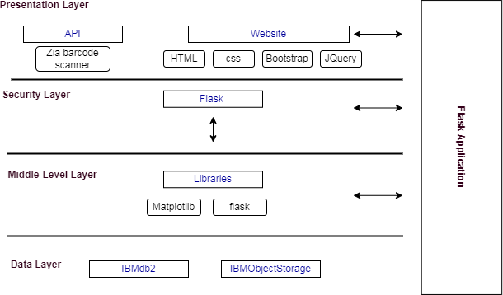

Table-1:Components&Technologies:

|  |  |  |  |
| --- | --- | --- | --- |
| **S.No** | **Component** | **Description** | **Technology** |
| 1 | UserInterface | WebUIwithChatbot | HTML,CSS,Bootstrap,Jquery |
| 2 | CalculatingProductsCount | Byenteringbarcodedetailsintotheapplication | ZiaBarcodeScanner |
| 3 | Showinghighdemandproduct | BytheproductsdatainIBMdb2 | Data Visualization usingPythonBarplotbyMatplotLibrary |
| 4. | AlertandNotification | Alertingtheretailersregardingthelowstockcountofthe  product | SendGrid |
| 5 | Chat | Chatwithwatsonassistant | IBMWatsonAssistant |
| 6 | CloudDatabase | DatabaseServiceonCloud | IBMDB2 |
| 7 | FileStorage | Filestoragerequirements | IBMObjectStorage |
| 8 | ExternalAPI-1Barcode | ToScantheproductbarcode | ZiaBarcodeScanner |
| 9 | Infrastructure(Server/Cloud) | CloudServerConfiguration | CloudFoundry,Kubernetes |

Table-2:ApplicationCharacteristics:

|  |  |  |  |
| --- | --- | --- | --- |
| **S.No** | **Characteristics** | **Description** | **Technology** |
| 1. | Open-SourceFrameworks | Stylingourpage,Pythonflaskmicroframework | PythonFlask,Bootstrap |
| 2. | SecurityImplementations | Forsecuringourclouddata | SSLCertificates |
| 3. | ScalableArchitecture | Three–tierarchitecture(MVC) | Webserver-HTML,CSS,Javascript  Applicationserver-PythonFlask,Docker, Container RegistryDatabaseserver-IBMDB2 |
| 4. | Availability | availabilityofapplication | IBMLoadBalancer |
| 5. | Performance | 5requestsperseconds,  UseofLocalMachineCacheMemory | IBMCloud,CDN |